{
"status": "Active"
}

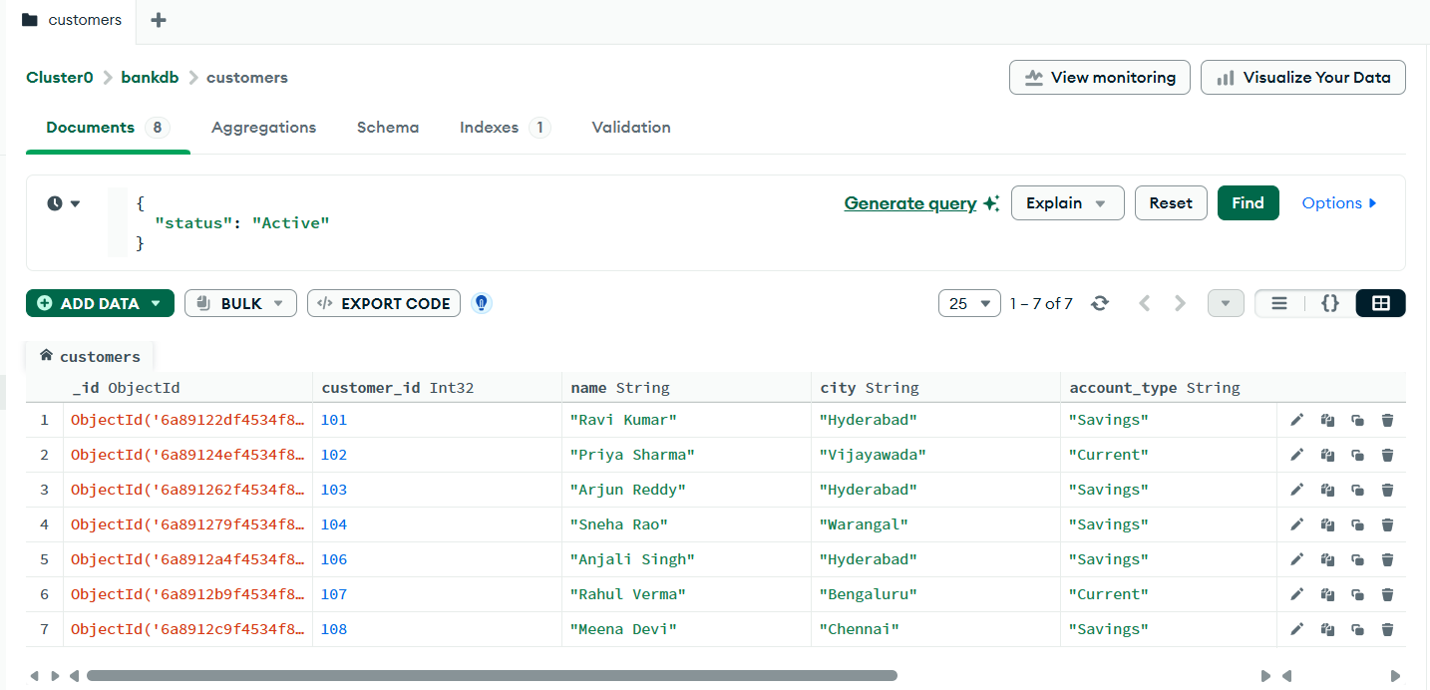

{
"balance": {
"$gt": 100000
}
}

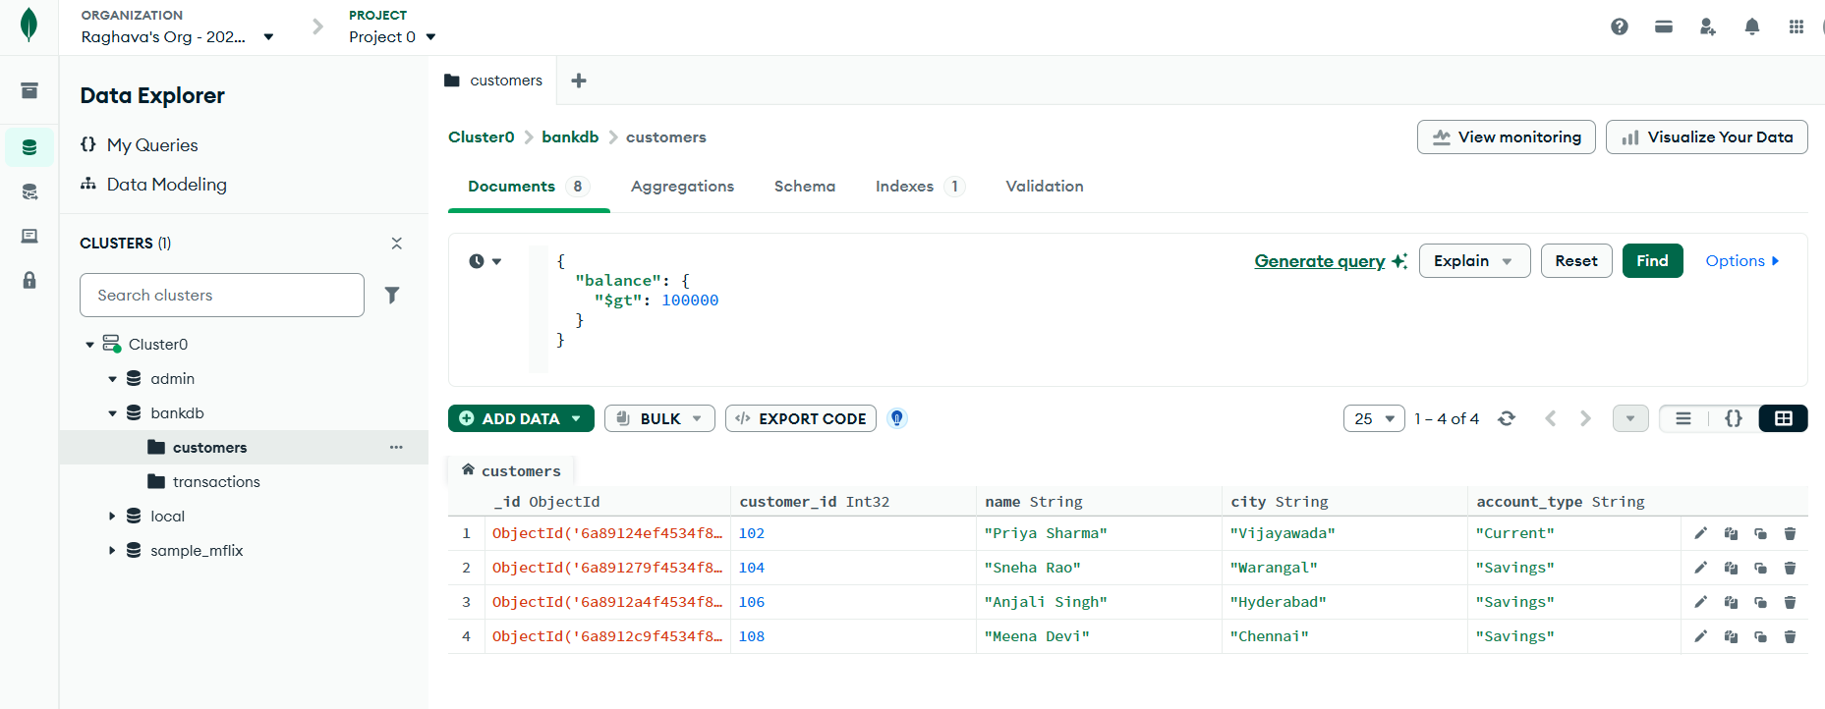
{
"city": "Hyderabad"
}
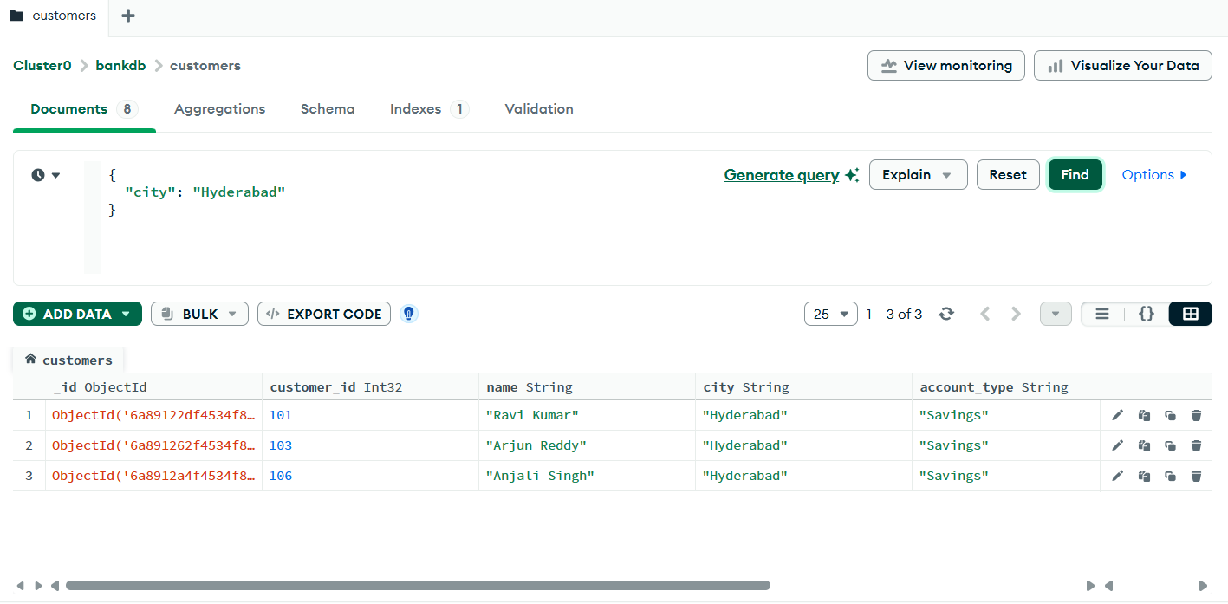
{
"account_type": "Savings"
}
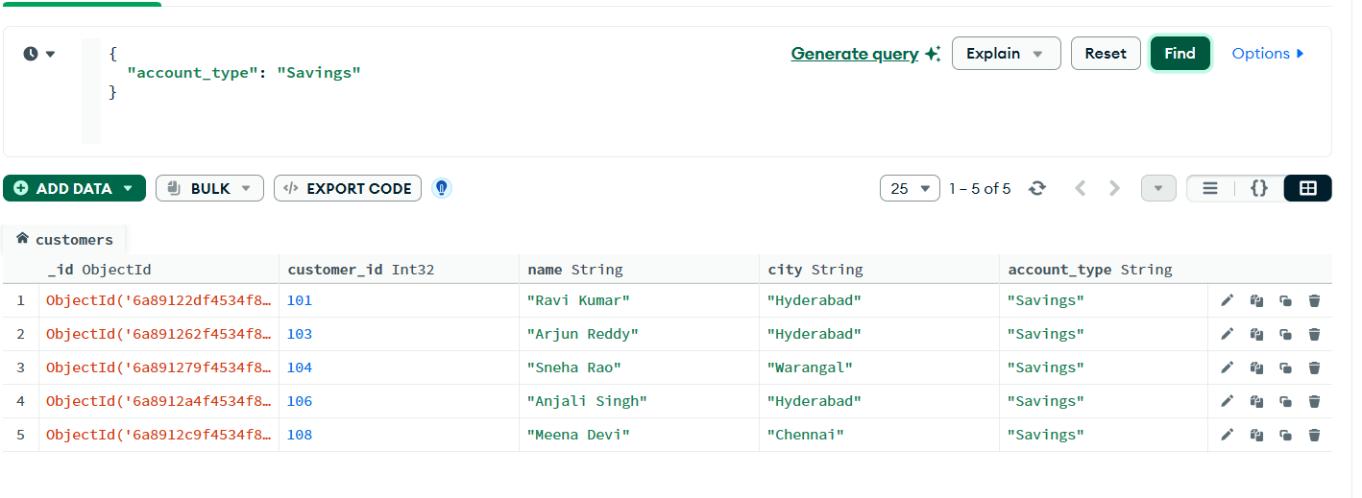
TRANSACTIONS

"amount": {
"$gt": 20000
}
}
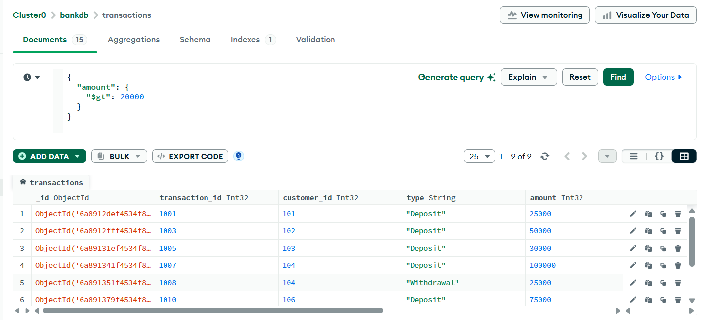

{
"type": "Deposit"
}

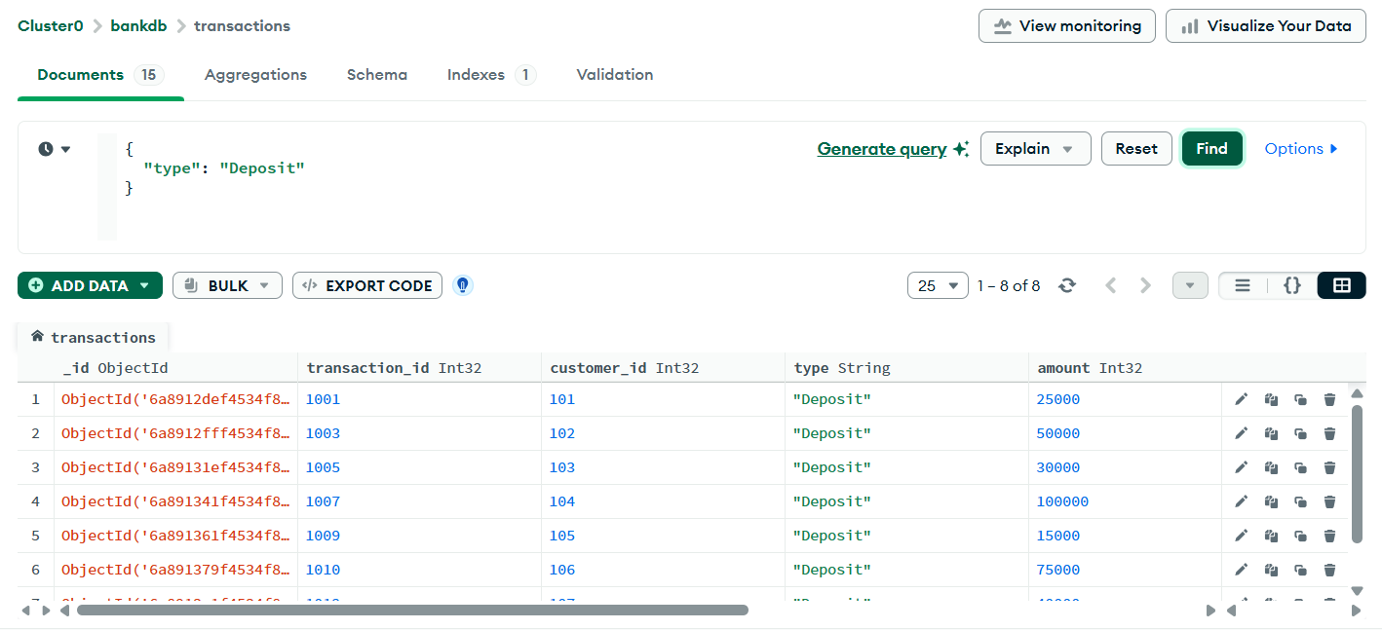
{
"mode": "ATM"
}
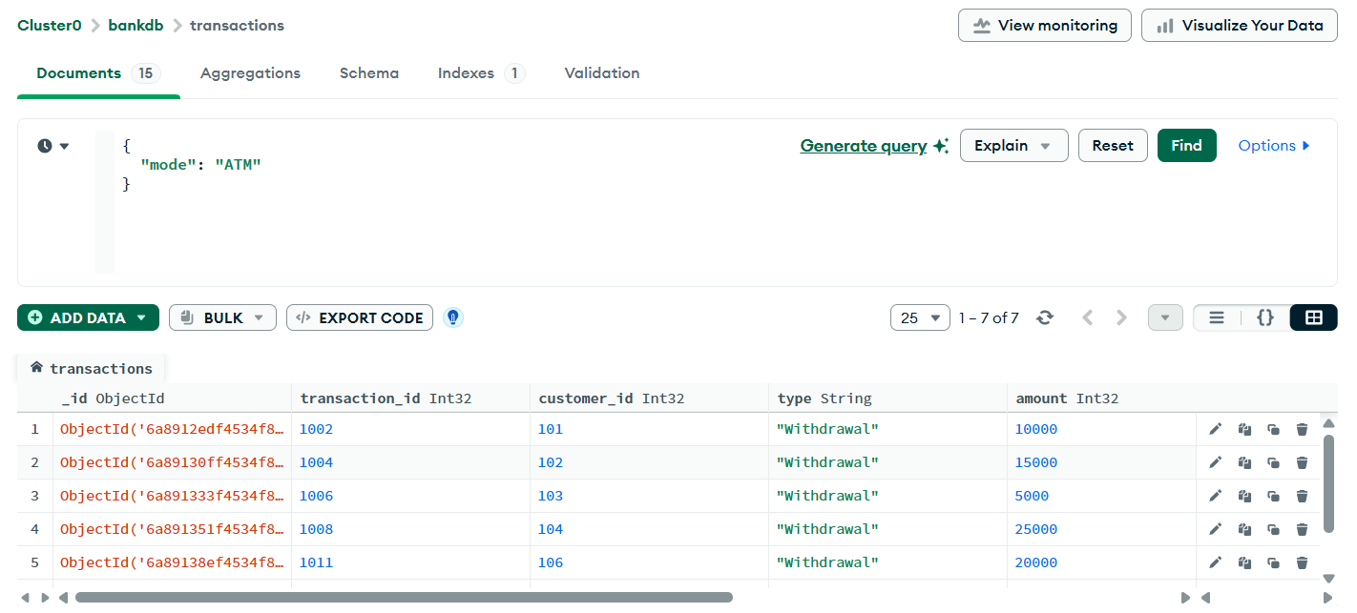
{
"type": "Deposit",
"amount": {
"$gt": 50000
}
}
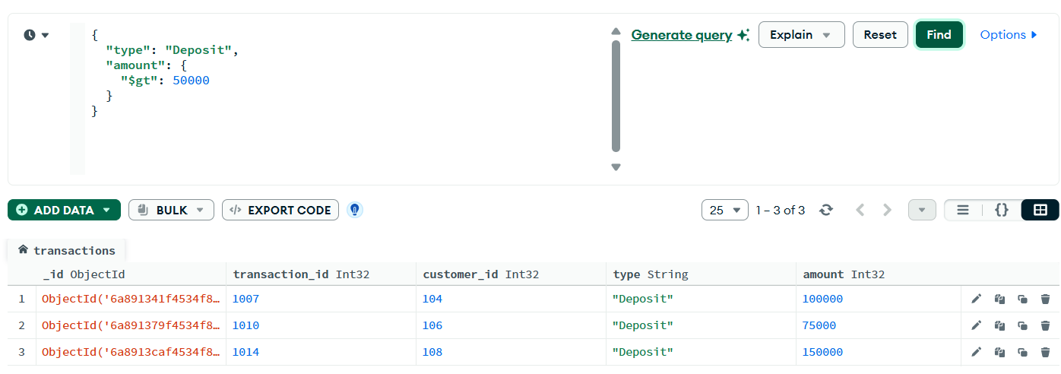

{
"city": "Hyderabad",
"balance": {
"$gt": 100000
}
}
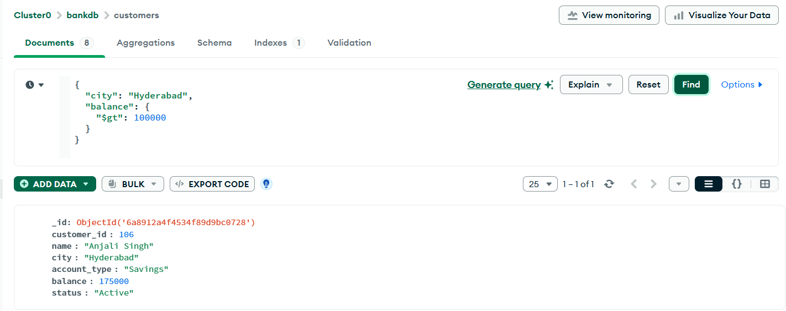
{
"city": {
"$in": [
"Hyderabad",
"Vijayawada",
"Warangal"
]
}
}
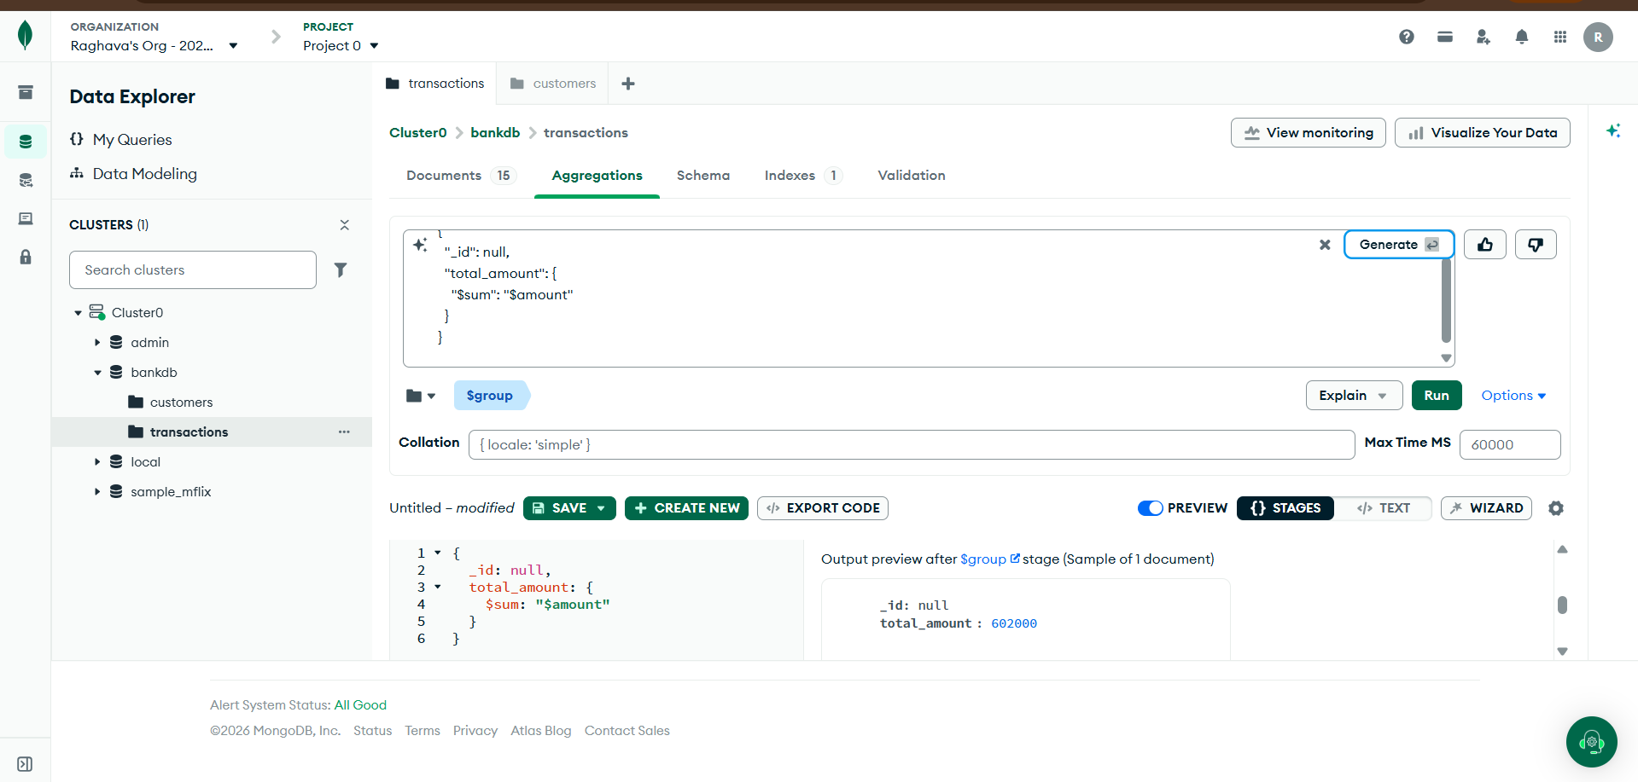

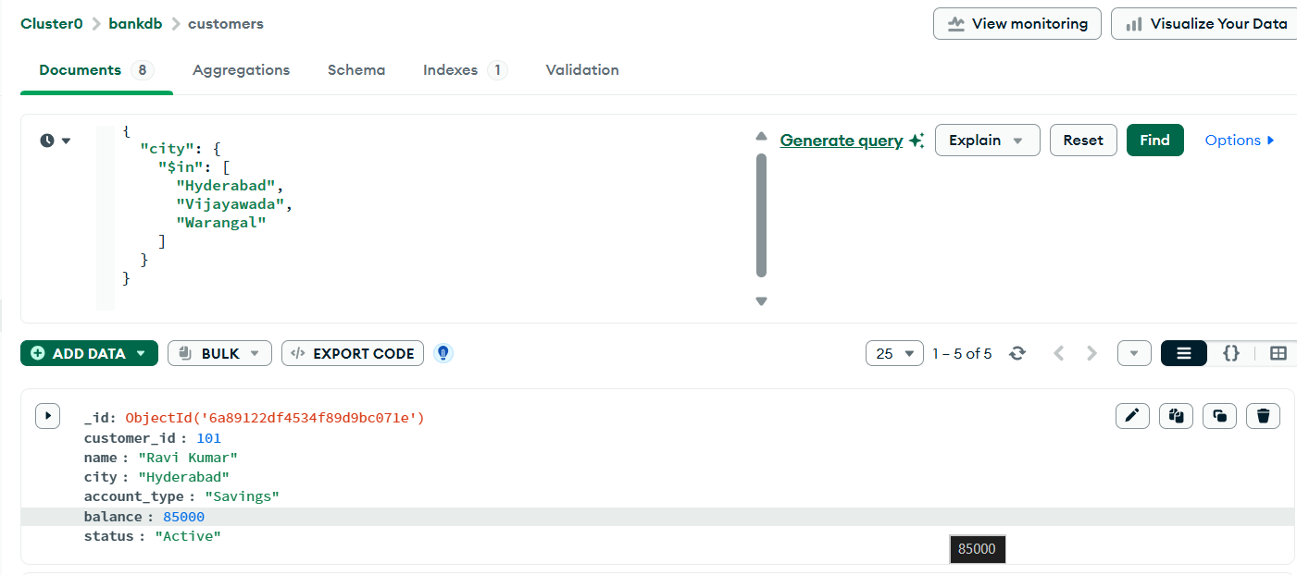
{
"_id": null,
"average_amount": {
"$avg": "$amount"
}
}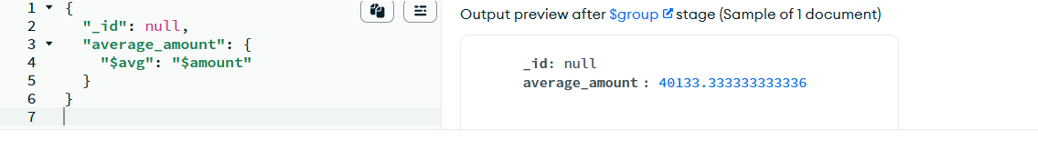
[
{
"$group": {
"_id": "$type",
"total_amount": {
"$sum": "$amount"
}
}
}
]
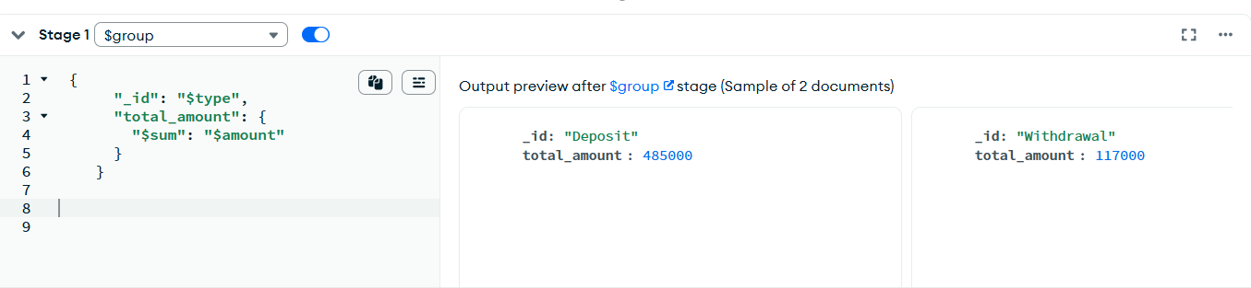

[
{
"$group": {
"_id": "$customer_id",
"transaction_count": {
"$sum": 1
}
}
},
{
"$sort": {
"transaction_count": -1
}
}
]
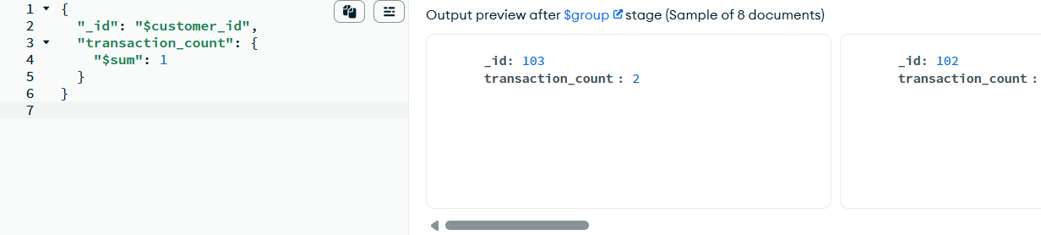
{
"from": "customers",
"localField": "customer_id",
"foreignField": "customer_id",
"as": "customer_details"
}
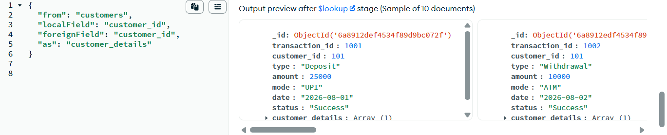

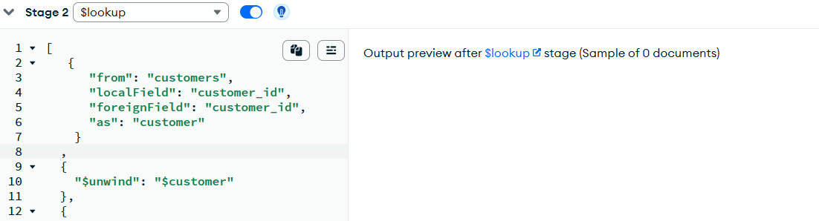
[
{
"$group": {
"_id": "$customer_id",
"total_transaction": {
"$sum": "$amount"
}
}
},
{
"$lookup": {
"from": "customers",
"localField": "_id",
"foreignField": "customer_id",
"as": "customer"
}
},
{
"$unwind": "$customer"
},
{
"$project": {
"_id": 0,
"customer_id": "$_id",
"customer_name": "$customer.name",
"total_transaction": 1
}
},
{
"$sort": {
"total_transaction": -1
}
}
]
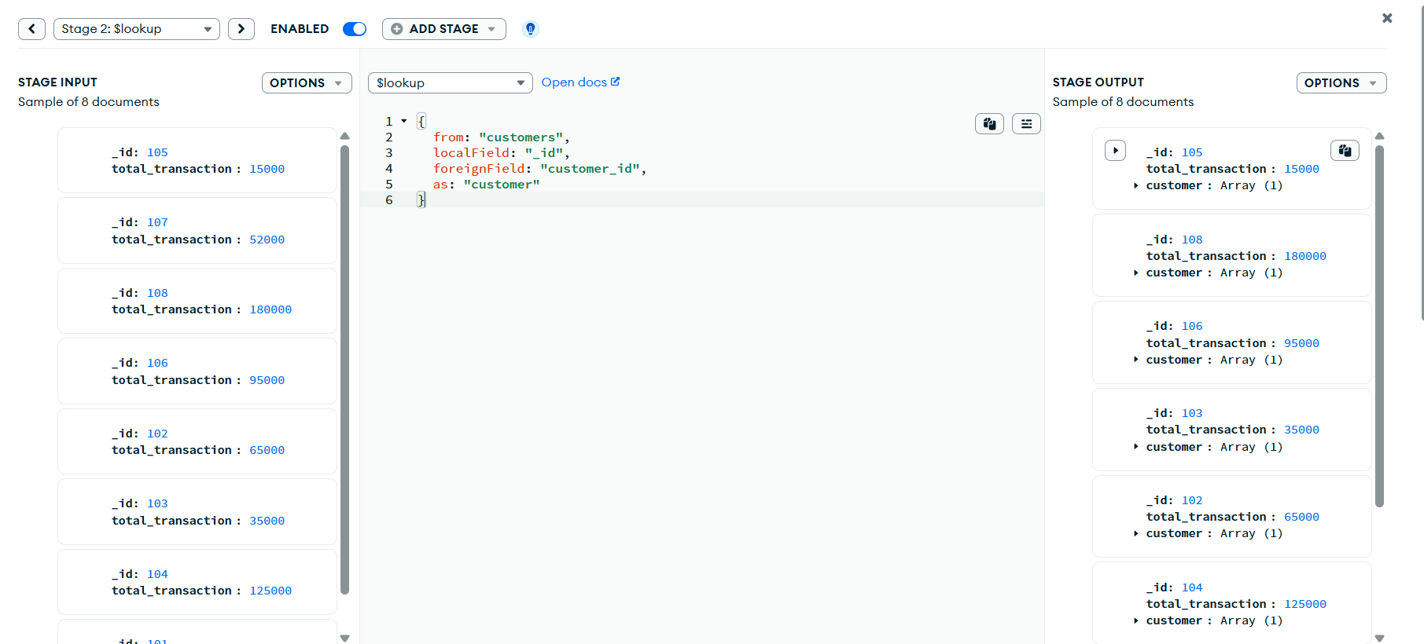

[
{
"$match": {
"status": "Active",
"balance": {
"$gt": 80000
}
}
},
{
"$lookup": {
"from": "transactions",
"localField": "customer_id",
"foreignField": "customer_id",
"as": "transactions"
}
},
{
"$unwind": "$transactions"
},
{
"$group": {
"_id": "$customer_id",
"customer_name": {
"$first": "$name"
},
"city": {
"$first": "$city"
},
"balance": {
"$first": "$balance"
},
"total_transactions": {
"$sum": "$transactions.amount"
},
"transaction_count": {
"$sum": 1
}
}
},
{
"$sort": {
"total_transactions": -1
}
}
]
